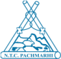
The Bharat Scouts and Guides, National Training Centre, Pachmarhi, M.P.– 461881
Ph. No. 07578 – 252026, E-Mail ntc@bsgindia.org www.bsgindia.org

NTC Cir.No.1 /2020/220/846 Dated : 7th Jan, 2021

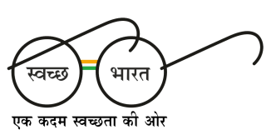
Only by E-mail
To,
All the State Secretaries,
State Associations of
The Bharat Scouts and Guides,
Indian Union

Sub : Online Youth Membership Portal – compliance by Trainers.

Ref : NHQ Circular NO. 02 / 2021.

Dear Sir/Madam,

As part of the digitization of membership details of The Bharat Scouts and Guides, an ambitious plan is being implemented by the National Headquarters with the support of State Associations.

The State Training Commissioners of both Scout and Guide wings may be requested to include a session on OYMS (Online Youth Membership Registration) as part of “How to start and Run a Units” in Basic Courses. All Trainers in the state be requested to register themselves as part of a Unit in their respective districts.

The National Training Centre will authenticate courses details of “Unit Leaders and Trainers” from OYMS portal from April, 2021. The Existing unit leaders be asked to update their training details in the portal so that the authentication can be done by the respective district/state officials.

Thanking you.

Yours in Scouting,

( Krishnaswamy R. )
Executive Director

Copy to :
- All the Office Bearers of National Associations.
- All the Asst. Directors, RHQ – for necessary follow up in their regions.
- The State Training Commissioner (S & G) for necessary action. The portal will have applications for Parchment, courses in due course of time hence it is mandatory for all unit leaders/trainers to register themselves in the membership portal.

